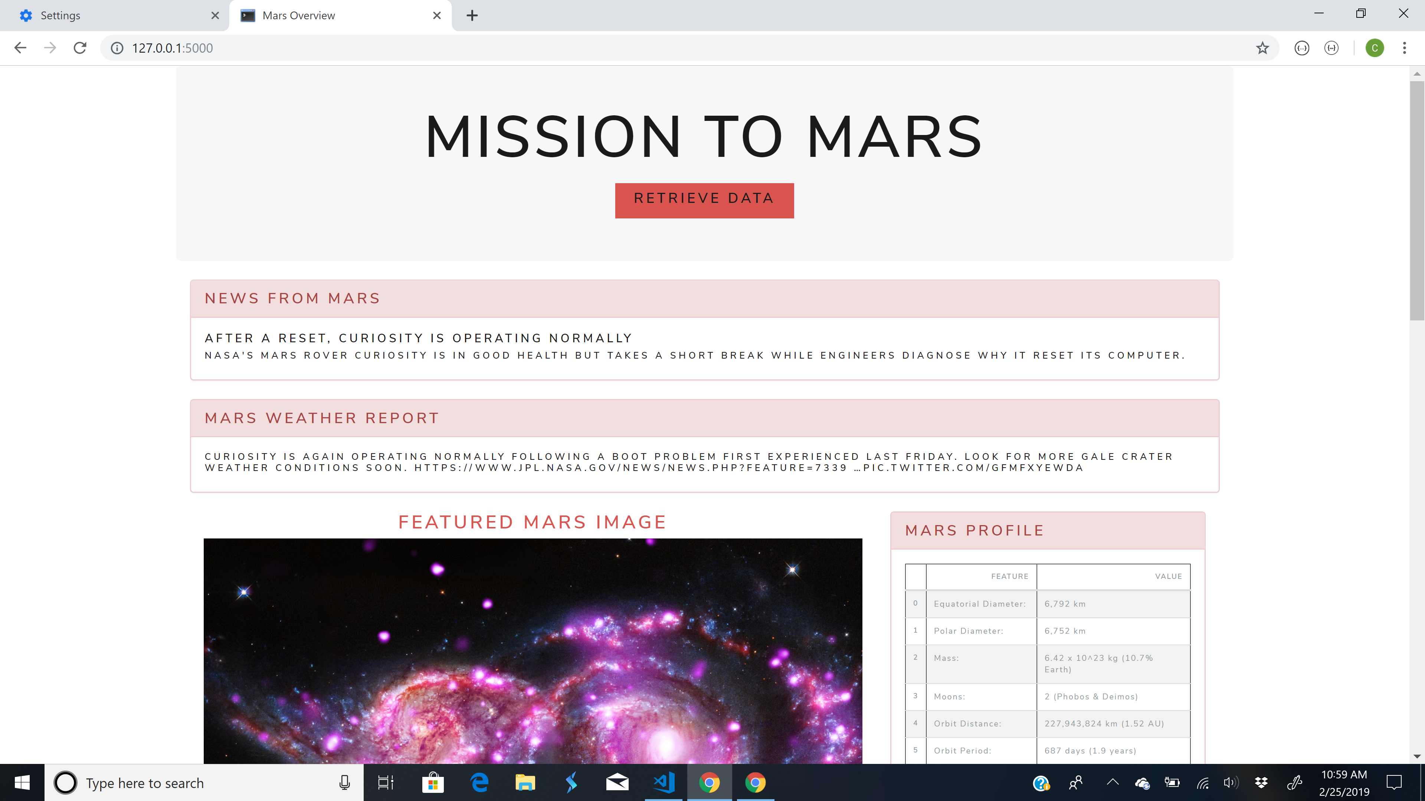

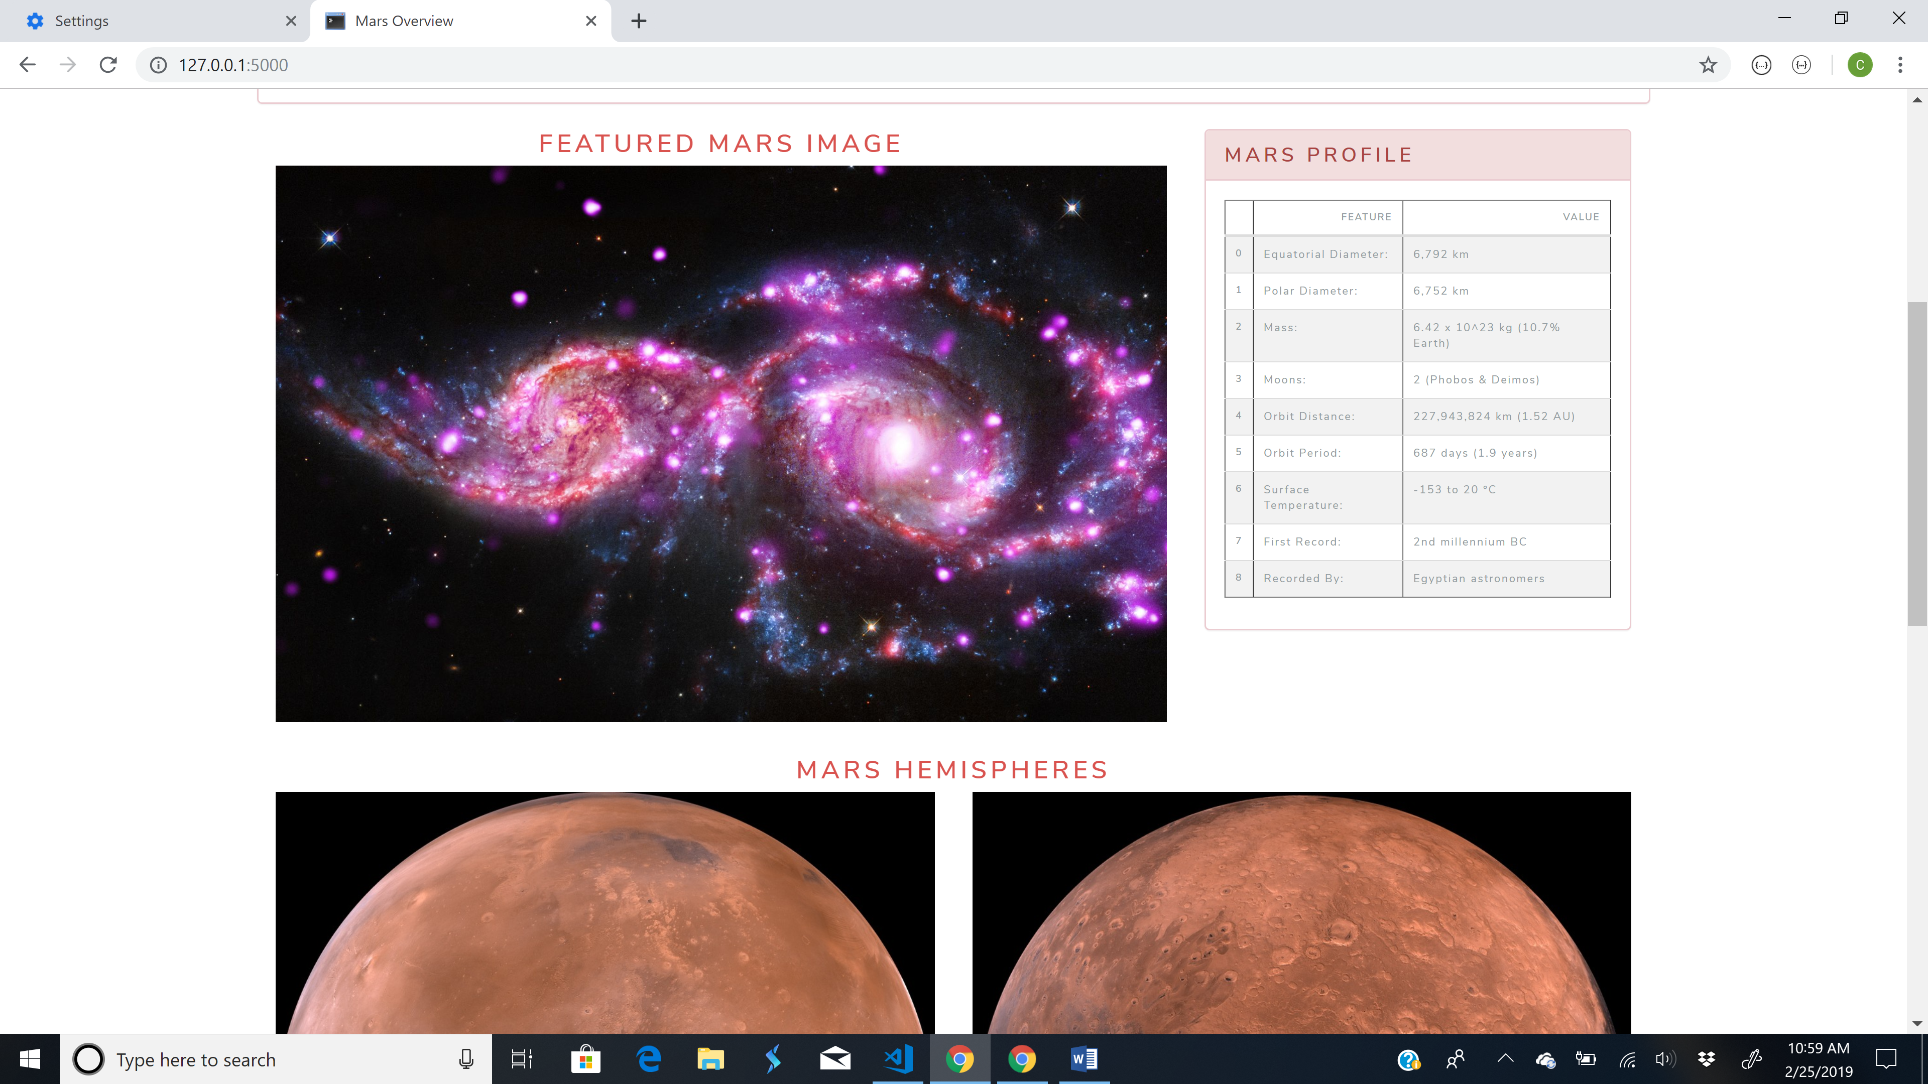

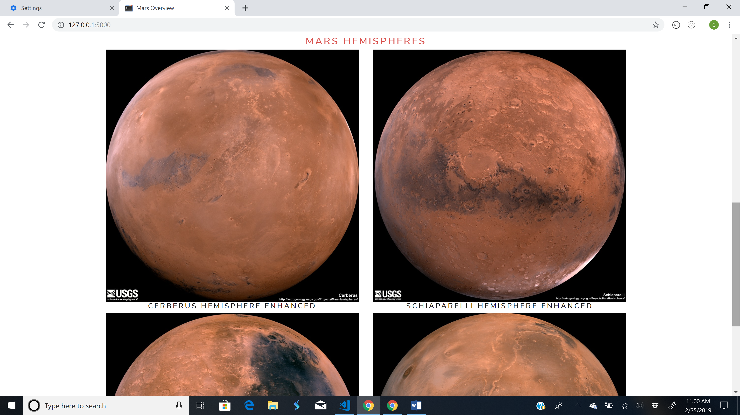

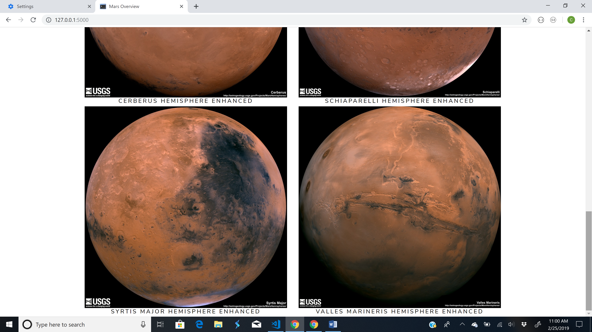

I included this document in the event you get an error when loading data. Sometimes, there is an error if the jpl image in the middle of a change or another site is down.

Challenges:

1. I struggled with the getting the Mars Profile Table to look the way that I wanted it to. I had wanted to set the index to ‘Features’, however when that happens the ‘Value’ title is higher and that is a pet peeve to me. I am not sure what is worse though, to have the numbered indexes or to have the header rows look offset. Also, I tried to center the text in the table with text-centered and only centered the body, not the header. I also tried to remove the header of the table with iloc, however that removed the first row of data not the header. So, I am not sure how to fix the table headers so this is aligned with the table body.
2. My tutor helped me with the loop to scrape in the hemisphere images.
3. My classmate introduced me to bootswatch (https://bootswatch.com/)
4. I also, moved the weather report from the right of the Featured Image to above that image and below the news report for aesthetic reasons, I did not like the white space trapped between the Featured image and the Mars Hemispheres. See below:

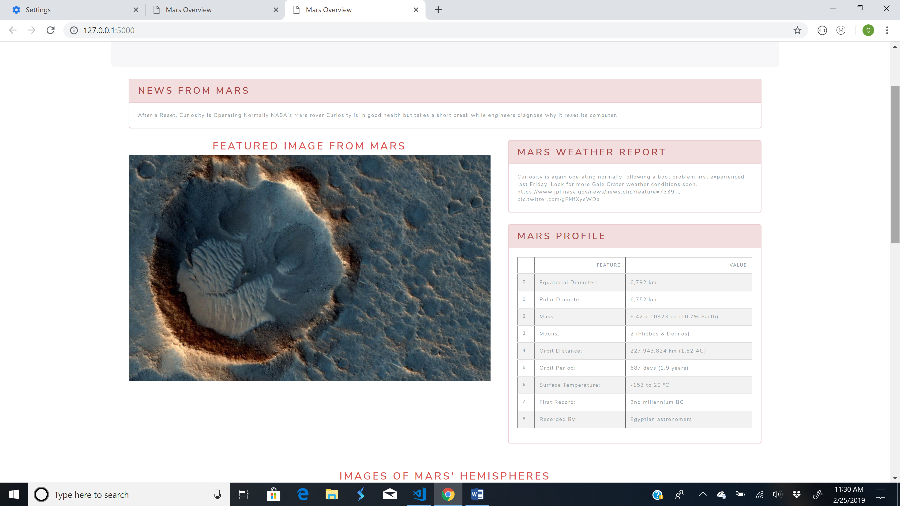

I prefer it to look more like this:

